
- How to access games on IWB and how to create representations of objects and people.
- How to photograph using an iPad and model how to retrieve information using search engines.
- To know how to use a keyboard to add own names to pictures created on computers.
- That a range of technology is used in places such as home and school –
- How to select and use these.

Vocabulary
Algorithm – steps to follow to achieve a task.
Sequence– a sequence of instructions that are followed in order.
Program –a sequence of instructions written to perform a specified task on the computer.
Debug – finding and correcting errors.
Personal Information–information to be kept private such as address/name.
Trusted Adult– someone you have a good relationship with that you trust such as a teacher or parent.
Online Bullying– a form of bullying using electronic means.
Processor- a machine that processes something (CPU).
Digital – any media created, edited or viewed on a computer.


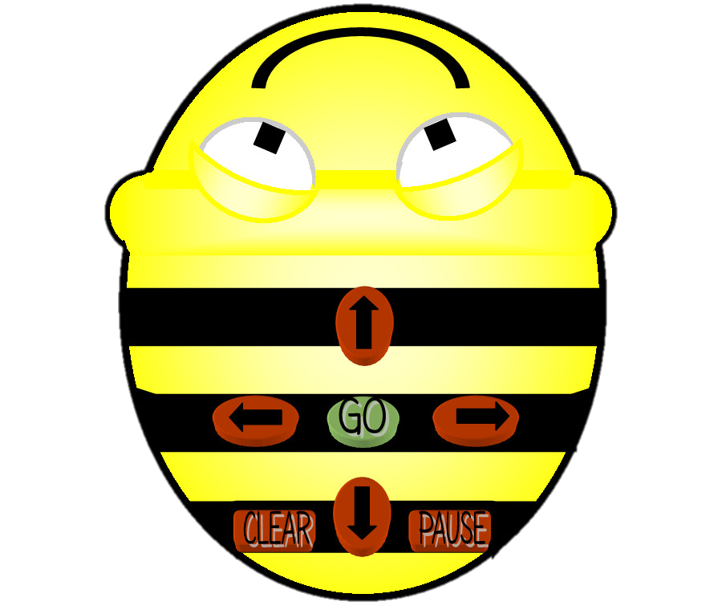

How to apply Maths knowledge of position and direction to Computing programs.
To understand that an algorithm is steps to follow to achieve a task – write a simple one.
I know how to create a simple program.

Topic: Computer Science
Year: 1
Waterloo Primary School – Computing Knowledge Organiser
What should I already know?
What will I know by the end of this unit of work?

