
- How to create simple algorithms using Bee-bots/Codapillar.
- How to remote control cars.
- How to access games on interactive boards.
- How to photograph using iPad
- How to use software on computers to create representations of people and objects.
- How create representations of objects and people on interactive boards.

Vocabulary
Algorithm – steps to follow to achieve a task.
Sequence– a sequence of instructions that are followed in order.
Program –a sequence of instructions written to perform a specified task on the computer.
Debug – finding and correcting errors.
Personal information–information to be kept private such as address/name.
Trusted Adult– someone you have a good relationship with that you trust such as a teacher or parent.
Online bullying– a form of bullying using electronic means.
Processor- a machine that processes something (CPU).
Digital – any media created, edited or viewed on a computer.


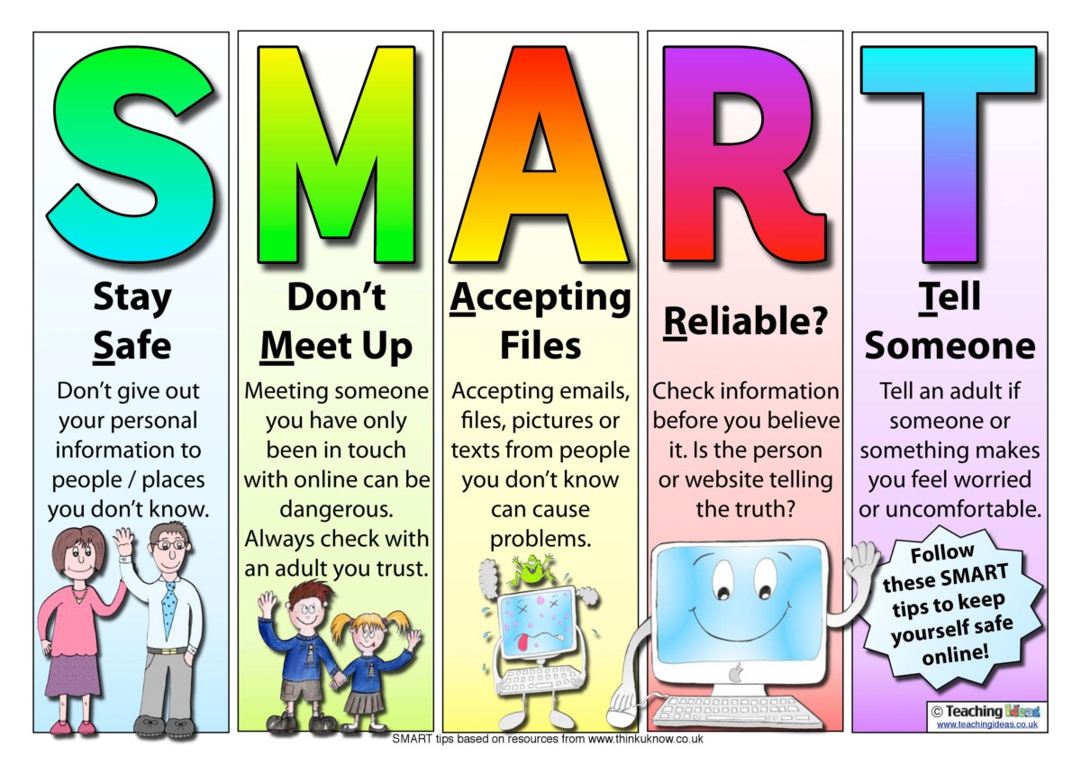

Understand the rules outlined by the school’s acceptable use policy.
Understand how to keep information private and why that is important.
I know common uses of technology beyond school.
I know that I must keep my information private and why.
I know how to keep my information private.
I know how to program Bee-Bot to follow a route

Topic: Digital Literacy
Year: 1
Waterloo Primary School – Computing Knowledge Organiser
What should I already know?
What will I know by the end of this unit of work?

